DATABASE PROJECT

**HEALTH INSURANCE VENDOR**

**PROJECT REPORT**

Muhammad Hammad: 21k-3181

Taha Ismail: 21k-3165



**Introduction:**

**The famous saying ‘health is wealth’, signifies the importance of health for all of us. Many people all over the world spend a lot of money on their and their family’s health care. In our society today, most of the people purchase or look to purchase health insurance for their households. To do this, the established norm has become to contact insurance clients, book a meeting with them, go through the whole negotiation process, then check other insurance companies to compare the prices and then finally make a decision to buy a health care insurance plan. This whole process is a lot of hassle. So, we have devised a plan to save people from spending so much time. We are providing people with an online platform where they can view healthcare insurance from top companies, compare the prices and purchase a plan which suits them. As well as booking appointments for visits.**

**Before Normalization:**

**USERS**

| **First_Name** | **Last_Name** | **Username** | **Password** | **Contact** | **Email** | **Address** |
| --- | --- | --- | --- | --- | --- | --- |

**Doctors**

| **doctor_id** | **FIRST_NAME** | **LAST_NAME** | **checkups** |
| --- | --- | --- | --- |

**national_insurance**

| **Username** | **insurance_id** | **Contact_Number** |
| --- | --- | --- |

**safeguard_insurance**

| **Username** | **insurance_id** | **Contact_Number** |
| --- | --- | --- |

**ubi_insurance**

| **Username** | **insurance_id** | **Contact_Number** |
| --- | --- | --- |

**visit**

| **user_id** | **doctor_id** | **visit_date** | **status** |
| --- | --- | --- | --- |

**payments**

| **payment_id** | **user_id** | **Amount_Due** | **Due_Year** | **credit_card** | **holdername** | **cvv** | **expiry** |
| --- | --- | --- | --- | --- | --- | --- | --- |

**AFTER NORMALIZATION**

**user**

| **First_Name** | **Last_Name** | **Username** | **Password** | **Address** |
| --- | --- | --- | --- | --- |



**User-contact**

| **Username** | **Contact** | **Email** |
| --- | --- | --- |



**payments**

| **payment_id** | **Amount_Due** | **Due_Year** | **credit_card** | **cvv** | **expiry** |
| --- | --- | --- | --- | --- | --- |

**Payer_info**

| **User_id** | **holdername** |
| --- | --- |

**Card_info**

| **credit_card** | **cvv** | **expiry** |
| --- | --- | --- |

**Doctors**

| **doctor_id** | **FIRST_NAME** | **LAST_NAME** | **checkups** |
| --- | --- | --- | --- |

**national_insurance**

| **Username** | **insurance_id** | **Contact_Number** |
| --- | --- | --- |

**safeguard_insurance**

| **Username** | **insurance_id** | **Contact_Number** |
| --- | --- | --- |

**ubi_insurance**

| **Username** | **insurance_id** | **Contact_Number** |
| --- | --- | --- |

**visit**

| **user_id** | **doctor_id** | **visit_date** | **status** |
| --- | --- | --- | --- |

**ERD DIAGRAM**

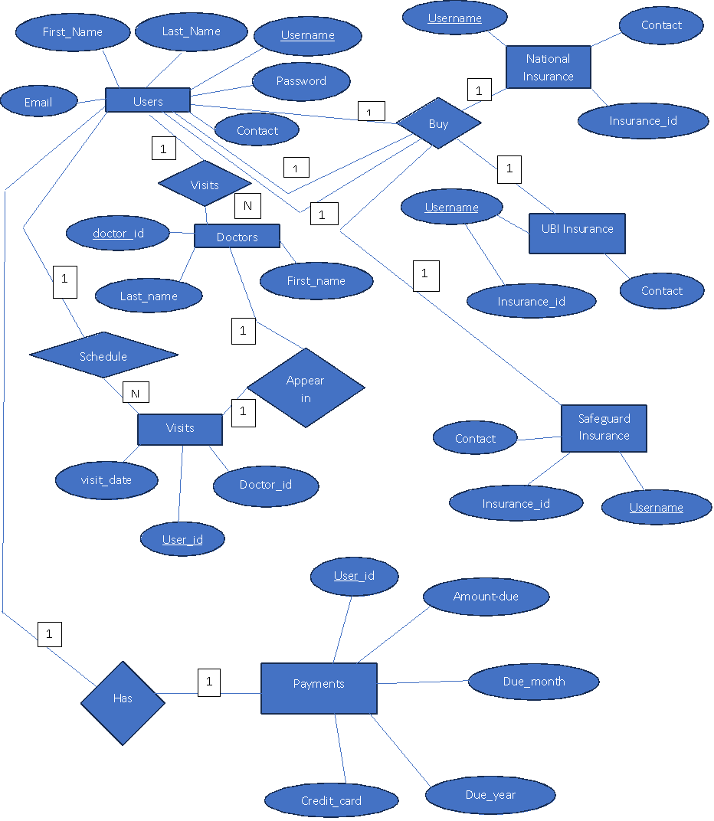

**PROJECT FEATURES:**

* User authentication: login through checking database stored username and password or register user by inserting his data in DB. The username and password validation are also provided in case the user enters the wrong password. As soon as the user registers, the data will be stored in the Data base.
* ⁠Dashboard: This feature provide ease to the user to choose multiple options to select from.
* ⁠Choosing Insurance plan:
* Customers will have the ability to view and compare the prices of different companies' health insurance. For now, we have provided three companies to choose the plan from and there will be a clear image to choose which suits them best and devise a payment plan.
* With respect to the insurance company chosen, they can also view the doctors available with the different insurance plans.
* After choosing insurance to buy, the user adds payments info. In this the user will provide his credit card details and in case of inputting invalid details, will be requested to enter again and when added successfully this info is added in DATABASE table Payments.
* Schedule visit option gives user chance to schedule a visit with any doctor from three doctors. A date is automatically created. In this feature, the date is selected one day ahead of the max date which means that for example the last date the doctor is having is 7/12/2023 and a new user comes so the date that will be selected will be 8/12/2023. This feature helps avoid date conflicts.
* TEANSACTION is used here to check if two users come at the same time to have a visit with the same doctor. So, doctors checkup column is incremented twice.
* ⁠User can also view all his due payments and the dates along with them.
* ⁠User can delete account. Here we use join statements to delete user from multiple tables by taking user id as the key.
* ADMIN FEATURE: Admin can first login. Then enter any user’s username to view all information which includes its appointment schedule and payment information and everything about that user. This means that admin has control over all the users.
* TRIGGER is used to make sure that if actual date has passed the scheduled visit date, then that visits status column will be turned from active to inactive.